| Please choose a lesson, or type 0 to return to course menu.

1: Principles of Analytic Graphs 2: Exploratory Graphs 3: Graphics Devices in R

4: Plotting Systems 5: Base Plotting System 6: Lattice Plotting System

7: Working with Colors 8: GGPlot2 Part1 9: GGPlot2 Part2

10: GGPlot2 Extras 11: Hierarchical Clustering 12: K Means Clustering

13: Dimension Reduction 14: Clustering Example 15: CaseStudy

Selection: 6

| Attemping to load lesson dependencies...

| Package ‘lattice’ loaded correctly!

| Package ‘ggplot2’ loaded correctly!

| | 0%

| Lattice_Plotting_System. (Slides for this and other Data Science courses may be found at github

| https://github.com/DataScienceSpecialization/courses/. If you care to use them, they must be downloaded as

| a zip file and viewed locally. This lesson corresponds to 04_ExploratoryAnalysis/PlottingLattice.)

...

|= | 1%

| In another lesson, we gave you an overview of the three plotting systems in R. In this lesson we'll focus

| on the lattice plotting system. As we did with the base plotting system, we'll focus on using lattice to

| create graphics on the screen device rather than another graphics device.

...

|=== | 3%

| The lattice plotting system is completely separate and independent of the base plotting system. It's an

| add-on package so it has to be explicitly loaded with a call to the R function library. We've done this

| for you. The R Documentation tells us that lattice "is an implementation of Trellis graphics for R. It is

| a powerful and elegant high-level data visualization system with an emphasis on multivariate data."

...

|==== | 4%

| Lattice is implemented using two packages. The first is called, not surprisingly, lattice, and it contains

| code for producing Trellis graphics. Some of the functions in this package are the higher level functions

| which you, the user, would call. These include xyplot, bwplot, and levelplot.

...

|====== | 6%

| If xyplot produces a scatterplot, what kind of plot does bwplot produce?

1: bad and wonderful

2: box and whisker

3: big and whittle

4: black and white

Selection: 2

| That's a job well done!

|======= | 7%

| The second package in the lattice system is grid which contains the low-level functions upon which the

| lattice package is built. You, the user, seldom call functions from the grid package directly.

...

|========= | 9%

| Unlike base plotting, the lattice system does not have a "two-phase" aspect with separate plotting and

| annotation. Instead all plotting and annotation is done at once with a single function call.

...

|========== | 10%

| The lattice system, as the base does, provides several different plotting functions. These include xyplot

| for creating scatterplots, bwplot for box-and-whiskers plots or boxplots, and histogram for histograms.

| There are several others (stripplot, dotplot, splom and levelplot), which we won't cover here.

...

|============ | 12%

| Lattice functions generally take a formula for their first argument, usually of the form y ~ x. This

| indicates that y depends on x, so in a scatterplot y would be plotted on the y-axis and x on the x-axis.

...

|============= | 13%

| Here's an example of typical lattice plot call, xyplot(y ~ x | f * g, data). The f and g represent the

| optional conditioning variables. The * represents interaction between them. Remember when we said that

| lattice is good for plotting multivariate data? That's where these conditioning variables come into play.

...

|=============== | 15%

| The second argument is the data frame or list from which the variables in the formula should be looked up.

| If no data frame or list is passed, then the parent frame is used. If no other arguments are passed, the

| default values are used.

...

|================ | 16%

| Recall the airquality data we've used before. We've loaded it again for you. To remind yourself what it

| looks like run the R command head with airquality as an argument to see what the data looks like.

> head(airquality)

Ozone Solar.R Wind Temp Month Day

1 41 190 7.4 67 5 1

2 36 118 8.0 72 5 2

3 12 149 12.6 74 5 3

4 18 313 11.5 62 5 4

5 NA NA 14.3 56 5 5

6 28 NA 14.9 66 5 6

| You are amazing!

|================== | 18%

| Now try running xyplot with the formula Ozone~Wind as the first argument and the second argument data set

| equal to airquality.

> xyplot(Ozone~Wind, data = airquality)

| Excellent job!

|=================== | 19%

| Look vaguely familiar? The dots are blue, instead of black, but lattice labeled the axes for you. You can

| use some of the same graphical parameters (e.g., pch and col) that you used in the base package in calls

| to lattice functions.

...

|===================== | 21%

| Now rerun xyplot with the formula Ozone~Wind as the first argument and the second argument data set equal

| to airquality (use the up arrow to save typing). This time add the arguments col set equal to "red", pch

| set equal to 8, and main set equal to "Big Apple Data".

> xyplot(Ozone~Wind, data = airquality, col = "red", pch = 8, main = "Big Apple Data")

| All that hard work is paying off!

|====================== | 22%

| Red snowflakes are cool, right? Now that youâ€™ve seen the basic xyplot() and some of its arguments, you

| might want to experiment more by yourself when you're done with the lesson to discover what other

| arguments and colors are available. (If you can't wait to experiment, recall that swirl has play() and

| nxt() functions. At a command prompt, typing play() allows you to leave swirl temporarily so you can try

| different R commands at the console. Typing nxt() when youâ€™re done playing brings you back to swirl and

| you can resume your lesson.)

...

|======================== | 24%

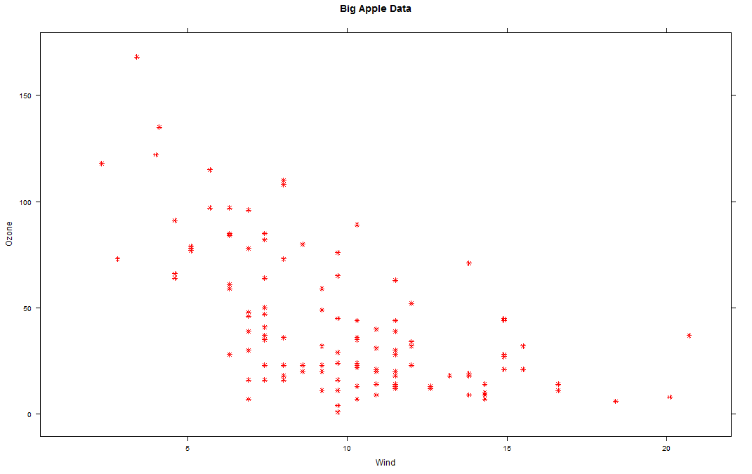

| Now you'll see how easy it is to generate a multipanel plot using a single lattice command.

...

|========================= | 25%

| Run xyplot with the formula Ozone~Wind | as.factor(Month) as the first argument and the second argument

| data set equal to airquality (use the up arrow to save typing). So far, not much is different, right? Add

| a third argument, layout, set equal to c(5,1).

> xyplot(Ozone~Wind | as.factor(Month), data = airquality, layout = c(5, 1))

| Keep up the great work!

|=========================== | 27%

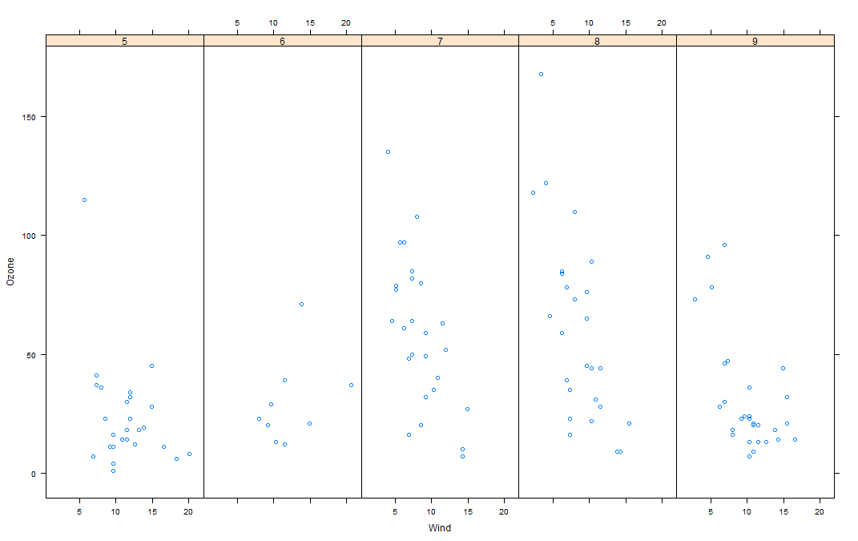

| Note that the default color and plotting character are back. What did the as.factor(Month) do?

1: Displayed the data by individual months

2: Huh?

3: Randomly divided the data into 5 panels

4: Displayed and labeled each subplot with the month's integer

Selection: 4

| Your dedication is inspiring!

|============================ | 28%

| Since Month is a named column of the airquality dataframe we had to tell R to treat it as a factor. To see

| how this affects the plot, rerun the xyplot command you just ran, but use Ozone ~ Wind | Month instead of

| Ozone ~ Wind | as.factor(Month) as the first argument.

> xyplot(Ozone~Wind | Month, data = airquality, layout = c(5, 1))

| Keep up the great work!

|============================== | 30%

| Not as informative, right? The word Month in each panel really doesn't tell you much if it doesn't

| identify which month it's plotting. Notice that the actual data is the same between the two plots, though.

...

|=============================== | 31%

| Lattice functions behave differently from base graphics functions in one critical way. Recall that base

| graphics functions plot data directly to the graphics device (e.g., screen, or file such as a PDF file).

| In contrast, lattice graphics functions return an object of class trellis.

...

|================================= | 33%

| The print methods for lattice functions actually do the work of plotting the data on the graphics device.

| They return "plot objects" that can be stored (but itâ€™s usually better to just save the code and data).

| On the command line, trellis objects are auto-printed so that it appears the function is plotting the

| data.

...

|================================== | 34%

| To see this, create a variable p which is assigned the output of this simple call to xyplot,

| xyplot(Ozone~Wind,data=airquality).

> p <- xyplot(Ozone~Wind, data = airquality)

| You got it!

|=================================== | 36%

| Nothing plotted, right? But the object p is around.

...

|===================================== | 37%

| Type p or print(p) now to see it.

> p

| Keep working like that and you'll get there!

|====================================== | 39%

| Like magic, it appears. Now run the R command names with p as its argument.

> names(p)

[1] "formula" "as.table" "aspect.fill" "legend" "panel"

[6] "page" "layout" "skip" "strip" "strip.left"

[11] "xscale.components" "yscale.components" "axis" "xlab" "ylab"

[16] "xlab.default" "ylab.default" "xlab.top" "ylab.right" "main"

[21] "sub" "x.between" "y.between" "par.settings" "plot.args"

[26] "lattice.options" "par.strip.text" "index.cond" "perm.cond" "condlevels"

[31] "call" "x.scales" "y.scales" "panel.args.common" "panel.args"

[36] "packet.sizes" "x.limits" "y.limits" "x.used.at" "y.used.at"

[41] "x.num.limit" "y.num.limit" "aspect.ratio" "prepanel.default" "prepanel"

| You are doing so well!

|======================================== | 40%

| We see that the trellis object p has 45 named properties, the first of which is "formula" which isn't too

| surprising. A lot of these properties are probably NULL in value. We've done some behind-the-scenes work

| for you and created two vectors. The first, mynames, is a character vector of the names in p. The second

| is a boolean vector, myfull, which has TRUE values for nonnull entries of p. Run mynames[myfull] to see

| which entries of p are not NULL.

> mynames[myfull]

[1] "formula" "as.table" "aspect.fill" "panel" "skip"

[6] "strip" "strip.left" "xscale.components" "yscale.components" "axis"

[11] "xlab" "ylab" "xlab.default" "ylab.default" "x.between"

[16] "y.between" "index.cond" "perm.cond" "condlevels" "call"

[21] "x.scales" "y.scales" "panel.args.common" "panel.args" "packet.sizes"

[26] "x.limits" "y.limits" "aspect.ratio" "prepanel.default"

| Keep up the great work!

|========================================= | 42%

| Wow! 29 nonNull values for one little plot. Note that a lot of them are like the ones we saw in the base

| plotting system. Let's look at the values of some of them. Type p[["formula"]] now.

> p[["formula"]]

Ozone ~ Wind

| Perseverance, that's the answer.

|=========================================== | 43%

| Not surprising, is it? It's a familiar formula. Now look at p's x.limits. Remember the double square

| brackets and quotes.

> p[["x.limits"]]

[1] 0.37 22.03

| You are quite good my friend!

|============================================ | 45%

| They match the plot, right? The x values are indeed between .37 and 22.03.

...

|============================================== | 46%

| Again, not surprising. Before we wrap up, let's talk about lattice's panel functions which control what

| happens inside each panel of the plot. The ease of making multi-panel plots makes lattice very appealing.

| The lattice package comes with default panel functions, but you can customize what happens in each panel.

...

|=============================================== | 48%

| Panel functions receive the x and y coordinates of the data points in their panel (along with any optional

| arguments). To see this, we've created some data for you - two 100-long vectors, x and y. For its first 50

| values y is a function of x, for the last 50 values, y is random. We've also defined a 100-long factor

| vector f which distinguishes between the first and last 50 elements of the two vectors. Run the R command

| table with f as it argument.

> table(f)

f

Group 1 Group 2

50 50

| Your dedication is inspiring!

|================================================= | 49%

| The first 50 entries of f are "Group 1" and the last 50 are "Group 2". Run xyplot with two arguments. The

| first is the formula y~x|f, and the second is layout set equal to c(2,1). Note that we're not providing an

| explicit data argument, so xyplot will look in the environment and see the x and y that we've generated

| for you.

> xyplot(y~x | f, layout = c(2, 1))

| Excellent work!

|================================================== | 51%

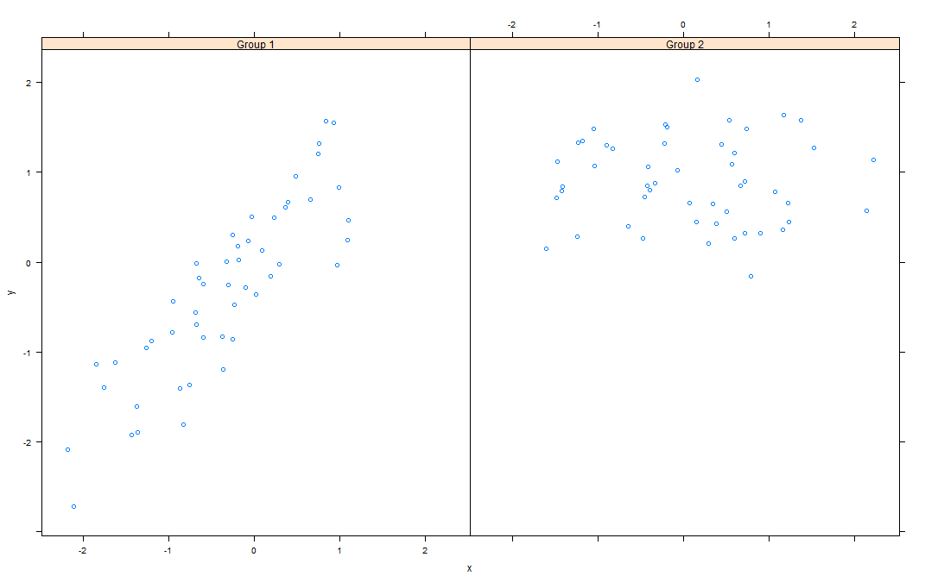

| To understand this a little better look at the variable v1 we've created for you.

> v1

[1] -2.185287 1.101780 -2.716851 1.569850

| Excellent work!

|==================================================== | 52%

| The first two numbers are the range of the x values of Group 1 and the last two numbers are the range of y

| values of Group 1. See how they match the values of the left panel (Group 1) in the plot. Now look at v2

| which holds the comparable numbers for Group 2.

> v2

[1] -1.6066772 2.2205197 -0.1605085 2.0341048

| You're the best!

|===================================================== | 54%

| Again, the values match the plot. That's reassuring. We've copied some code from the slides for you. To

| see it, type myedit("plot1.R"). This will open your editor and display the R code in it.

> myedit("plot1.R")

| That's the answer I was looking for.

|======================================================= | 55%

p <- xyplot(y ~ x | f, panel = function(x, y, ...) {

panel.xyplot(x, y, ...) ## First call the default panel function for 'xyplot'

panel.abline(h = median(y), lty = 2) ## Add a horizontal line at the median

})

print(p)

invisible()

| How many calls to xyplot are there?

1: 1

2: 2

3: 3

Selection: 1

| That's the answer I was looking for.

|======================================================== | 57%

| Note the panel function. How many formal arguments does it have?

1: 2

2: 3

3: 1

Selection: 2

| All that hard work is paying off!

|========================================================== | 58%

| The panel function has 3 arguments, x, y and ... . This last stands for all other arguments (such as

| graphical parameters) you might want to include. There are 2 lines in the panel function. Each invokes a

| panel method, the first to plot the data in each panel (panel.xyplot), the second to draw a horizontal

| line in each panel (panel.abline). Note the similarity of this last call to that of the base plotting

| function of the same name.

...

|=========================================================== | 60%

| We've defined a function for you, pathtofile, which takes a filename as its argument. This makes sure R

| can find the file on your computer. Now run the R command source with two arguments. The first is the call

| to pathtofile with the string "plot1.R" as its argument and the second is the argument local set equal to

| TRUE. This command will run the code contained in plot1.R within the swirl environment so you can see what

| it does.

> source(pathtofile("plot1.R"), local = TRUE)

| Excellent job!

|============================================================= | 61%

| See how the lines appear. The plot shows two panels because...?

1: there are 2 variables

2: there are 2 calls to panel methods

3: f contains 2 factors

4: lattice can handle at most 2 panels

Selection: 3

| You are amazing!

|============================================================== | 63%

| We've copied another piece of similar code, i.e., a call to xyplot with a custom panel function, from the

| slides. To see it, type myedit("plot2.R"). This will open your editor and display the R code in it.

> myedit("plot2.R")

| That's correct!

|================================================================ | 64%

p2 <- xyplot(y ~ x | f, panel = function(x, y, ...) {

panel.xyplot(x, y, ...) ## First call default panel function

panel.lmline(x, y, col = 2) ## Overlay a simple linear regression line

})

print(p2)

invisible()

| You can see how plot2.R differs from plot1.R, right?

...

|================================================================= | 66%

| Again, run the R command source with the two arguments pathtofile("plot2.R") and local=TRUE. This will run

| the code in plot2.R.

> source(pathtofile("plot2.R"), local = TRUE)

| You nailed it! Good job!

|================================================================== | 67%

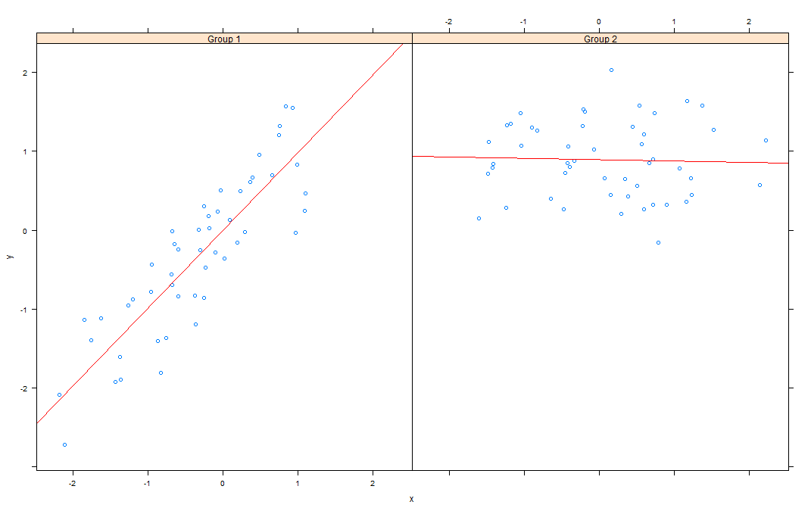

| The regression lines are red because ...?

1: the custom panel function specified a col argument

2: R always plots regression lines in red

3: R is the first letter of the word red

Selection: 1

| All that hard work is paying off!

|==================================================================== | 69%

| Before we close we'll look at how easily lattice can handle a plot with a great many panels. (The sky's

| the limit.) We've loaded some diamond data for you. It comes with the ggplot2 package. We'll use it just

| to show off lattice's panel plotting capability.

...

|===================================================================== | 70%

| The data is in the data frame diamonds. Use the R command str to see what it looks like.

> str(diamonds)

Classes ‘tbl_df’, ‘tbl’ and 'data.frame': 53940 obs. of 10 variables:

$ carat : num 0.23 0.21 0.23 0.29 0.31 0.24 0.24 0.26 0.22 0.23 ...

$ cut : Ord.factor w/ 5 levels "Fair"<"Good"<..: 5 4 2 4 2 3 3 3 1 3 ...

$ color : Ord.factor w/ 7 levels "D"<"E"<"F"<"G"<..: 2 2 2 6 7 7 6 5 2 5 ...

$ clarity: Ord.factor w/ 8 levels "I1"<"SI2"<"SI1"<..: 2 3 5 4 2 6 7 3 4 5 ...

$ depth : num 61.5 59.8 56.9 62.4 63.3 62.8 62.3 61.9 65.1 59.4 ...

$ table : num 55 61 65 58 58 57 57 55 61 61 ...

$ price : int 326 326 327 334 335 336 336 337 337 338 ...

$ x : num 3.95 3.89 4.05 4.2 4.34 3.94 3.95 4.07 3.87 4 ...

$ y : num 3.98 3.84 4.07 4.23 4.35 3.96 3.98 4.11 3.78 4.05 ...

$ z : num 2.43 2.31 2.31 2.63 2.75 2.48 2.47 2.53 2.49 2.39 ...

| Keep up the great work!

|======================================================================= | 72%

| So the data frame contains 10 pieces of information for each of 53940 diamonds. Run the R command table

| with diamonds$color as an argument.

> table(diamonds$color)

D E F G H I J

6775 9797 9542 11292 8304 5422 2808

| You are amazing!

|======================================================================== | 73%

| We see 7 colors each represented by a letter. Now run the R command table with two arguments,

| diamonds$color and diamonds$cut.

> table(diamonds$color, diamonds$cut)

Fair Good Very Good Premium Ideal

D 163 662 1513 1603 2834

E 224 933 2400 2337 3903

F 312 909 2164 2331 3826

G 314 871 2299 2924 4884

H 303 702 1824 2360 3115

I 175 522 1204 1428 2093

J 119 307 678 808 896

| Keep working like that and you'll get there!

|========================================================================== | 75%

| We see a 7 by 5 array with counts indicating how many diamonds in the data frame have a particular color

| and cut. From the table, which is the most frequent combination?

1: Ideal color of cut G

2: Ideal cut of color F.

3: Ideal cut of color G

4: Premium cut of color G

Selection: 3

| Your dedication is inspiring!

|=========================================================================== | 76%

| To save you some trouble we've defined three character strings for you, labels for the x- and y-axes and a

| main title. They're in the file myLabels.R, so run myedit on this file to see them. Remember to put the

| file name in quotes when you call myedit.

> myedit("myLabels.R")

| Excellent job!

|============================================================================= | 78%

myxlab <- "Carat"

myylab <- "Price"

mymain <- "Diamonds are Sparkly!"

| Now run source with pathtofile("myLabels.R") and local set equal to TRUE.

> source(pathtofile("myLabels.R"), local = TRUE)

| Excellent work!

|============================================================================== | 79%

| Now call xyplot with the formula price~carat | color*cut and data set equal to diamonds. In addition, set

| the argument strip equal to FALSE, pch set equal to 20, xlab to myxlab, ylab to myylab, and main to

| mymain. The plot may take longer than previous plots because it is bigger.

> xyplot(price~carat | color*cut, diamonds, strip = FALSE, pch = 20, xlab = myxlab, ylab = myylab, main = mymain)

| Keep working like that and you'll get there!

|================================================================================ | 81%

| Pretty cool, right? 35 panels, one for each combination of color and cut. The dots (pch=20) show how prices

| for the diamonds in each category (panel) vary depending on carat.

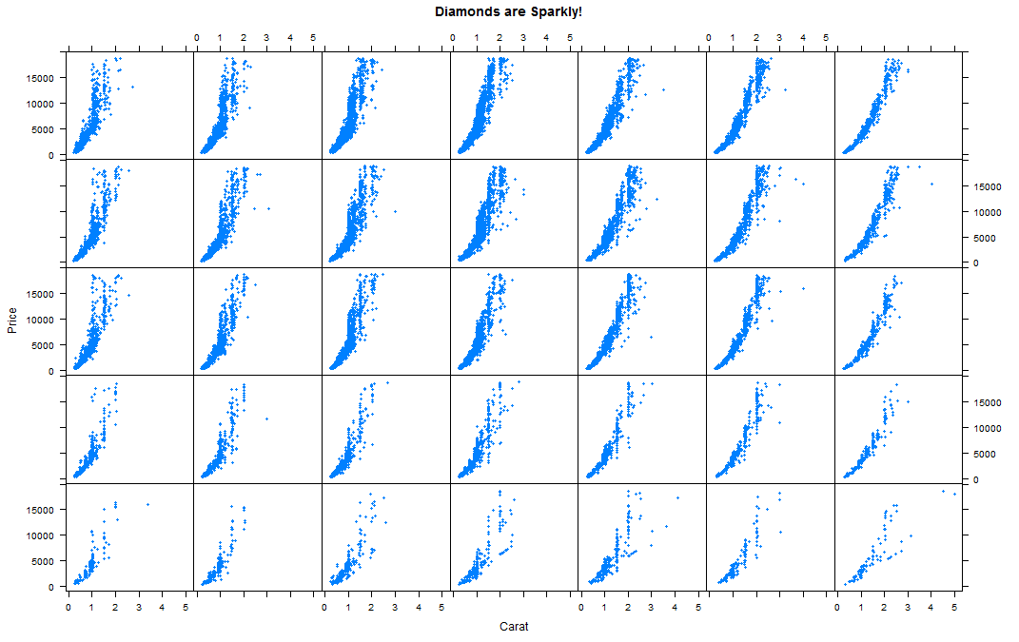

|================================================================================= | 82%

| Are colors defining the rows or columns of the plot?

1: rows

2: columns

Selection: 2

| Keep up the great work!

|=================================================================================== | 84%

| Were you curious about that argument strip? I know I was. Now rerun the xyplot command you just ran (use the

| up arrow key to retrieve it), this time without the strip argument.

> xyplot(price~carat | color*cut, diamonds, pch = 20, xlab = myxlab, ylab = myylab, main = mymain)

| You are amazing!

|==================================================================================== | 85%

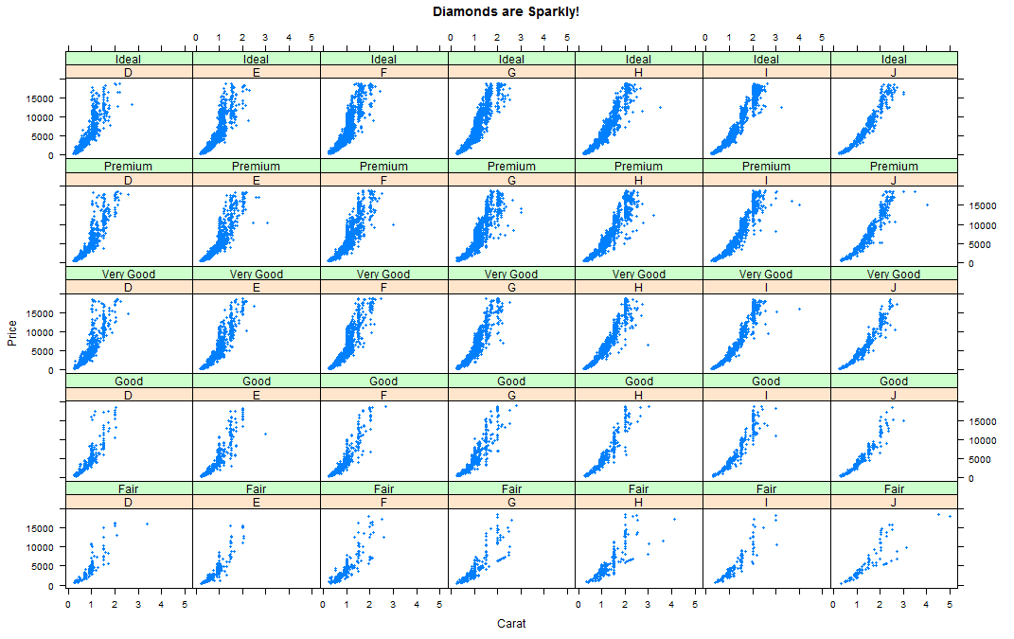

| The plot shows that the strip argument ....

1: labels each panel

2: makes the plot less intelligible

3: removes information from the plot

4: has a default value of FALSE

Selection: 1

| You got it right!

|====================================================================================== | 87%

| Review time!!!

...

|======================================================================================= | 88%

| True or False? Lattice plots are constructed by a series of calls to core functions.

1: True

2: False

Selection: 2

| You nailed it! Good job!

|========================================================================================= | 90%

| True or False? Lattice plots are constructed with a single function call to a core lattice function (e.g.

| xyplot)

1: True

2: False

Selection: 1

| You are amazing!

|========================================================================================== | 91%

| True or False? Aspects like margins and spacing are automatically handled and defaults are usually

| sufficient.

1: True

2: False

Selection: 1

| Keep working like that and you'll get there!

|============================================================================================ | 93%

| True or False? The lattice system is ideal for creating conditioning plots where you examine the same kind

| of plot under many different conditions.

1: False

2: True

Selection: 2

| All that practice is paying off!

|============================================================================================= | 94%

| True or False? The lattice system, like the base plotting system, returns a trellis plot object.

1: True

2: False

Selection: 2

| You are quite good my friend!

|=============================================================================================== | 96%

| True or False? Panel functions can NEVER be customized to modify what is plotted in each of the plot

| panels.

1: True

2: False

Selection: 2

| You nailed it! Good job!

|================================================================================================ | 97%

| True or False? Lattice plots can display at most 20 panels in a single plot.

1: False

2: True

Selection: 1

| Excellent job!

|================================================================================================== | 99%

| Congrats! We hope this lesson didn't leave you climbing the trellis.

...

|===================================================================================================| 100%